Instructions for Starting Jupyter

If you have not done so, please download the datasets referred to in the instructions in this link:

<https://www.coursera.org/learn/big-data-integration-processing/supplement/r8sXi/instructions-for-downloading-hands-on-datasets>

Many of the Hands On exercises in this course are executed in a Jupyter Notebook. To start Jupyter, open a new terminal window and run *pyspark*:

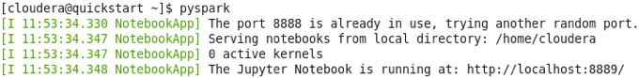

This will start Firefox (if not already running), and open a new tab showing the current directory:

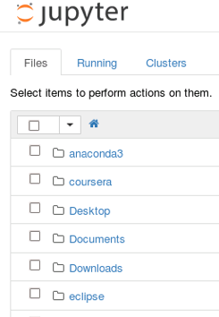

You can find the notebooks for this course in the *Downloads/big-data-3* directory. Click on *Downloads* and then click on *big-data-3*.

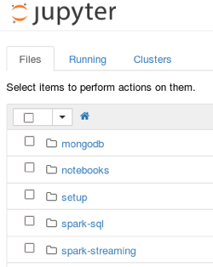

You can open Jupyter Notebooks by clicking on the *.ipynb* files.

When you are done, Jupyter can be stopped by entering *control-c* in the terminal window and then entering *yes.*